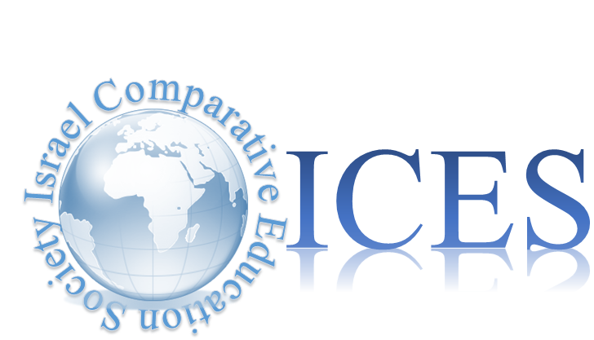
The Third National Conference – The Israel Comparative Education Society
Education in the Post-Truth Era

09:00 – 19:00, Thursday 17 January, 2019, Ben-Gurion University
Call for Papers

Final date for submission of abstracts & panels, 15 October, 2018
Please send proposals to
ices.israel.info@gmail.com

The third conference of the Israel Comparative Education Society will be held on Thursday 17 January 2019 at Ben-Gurion University. The Israel Comparative Education Society aims to advance research and discourse on major topics in education in the global era, from diverse viewpoints and disciplines (sociology, anthropology, and psychology of education, education economics, and political aspects of education). The Society welcomes works engaging with comparison between local case-studies, as well as those dealing with research on global and international aspects of education, such as assessment and evaluation, neoliberalism in education, global citizenship education, peace education, migration and education, Holocaust memory and genocide education, educating for human rights, gender, religion and education rights.

A central theme of the second annual conference will education in the post-truth era, however, we invite the submission of abstracts from researchers who are engaged in other comparative aspects of education from an assortment of perspectives. We believe that the conference is an arena for presenting and discussing diverse topics in comparative and international education, as well as an opportunity to promote comparative research in education.
We hope to encourage research students who integrate, or are considering to integrate comparative aspects, to submit abstracts or proposals for panels. Abstracts should include the research goals, the theoretical framework, methodology and findings, and should not exceed 350 words. Proposals for panels should contain the rationale for the proposed panel (250 words) and abstracts of the participating researchers (250 words each).
Conference Program:
Keynote Speaker
Prof. David Post
Penn State University
Department of Education Policy Studies
President Elect of the CIES
Does Education Increase Environmentalism and Global Citizenship? A Cross-national Analysis of the World Values Survey

The conference program also includes a central panel that will discuss the conference’s central theme – Education in the Post-Truth era and another guest lecture by Prof. Tristan McCowan, UCL on ‘The unbundling of higher education’ , and parallel sessions of both established researchers and research students.
The Organizing Committee (in alphabetical order): Dr. Ayman Agbaria (Haifa University); Prof. Zehavit Gross (Bar-Illan University), Dr. Halleli Pinson (Ben-Gurion University); Dr. Julia Resnik (The Hebrew University) and; Dr. Miri Yemini (Tel-Aviv University).

